**Hariprasanth.B**

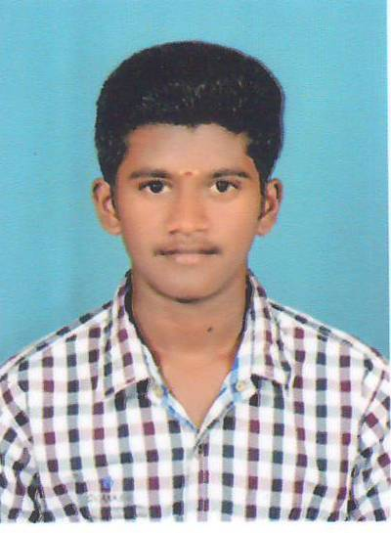

5/6,Govindan Chettiyar Street,

Mallur(PO),Salem(DT)-636 203

Contact No: (+91) 87547 09170

E-Mail ID: hariprasanthbemech@gmail.com

## CAREER OBJECTIVE:

To be in position in a company that seeks ambitious and career conscious person where acquired skills and education will be utilized towards continuous growth, development and handling skills.

## ACADEMIC QUALIFICATIONS:

|  |  |  |  |
| --- | --- | --- | --- |
| **Qualification** | **Institution** | **Years of Study** | **Percentage (%)** |
| **B.E.**  ( Mechanical  Engineering ) | Mahendra Institute of Engineering and Technology In Namakkal | (2013-2017) | 65% |
| **HSC** | Govt.Boys.Hig.Sec.School  Vennandur | 2013 | 61.75% |
| **S.S.L.C** | Govt.Boys.Hig.Sec.School  Vennandur | 2011 | 81.4% |

## ACADEMIC ACHIVEMENT:

* Got 100% attendance in the academic year 2013-2015.
* Scored First rank in engineering 7th semester.

## FIELD OF INTEREST:

* Power Plant Engineering.
* Manufacturing Technology.
* Design Engineering.
* Maintenance Engineering.

## TECHNICAL SKILLS:

* PRO-E.
* BASIC AUTO-CAD.
* ANSYS.

## PROJECTS UNDERTAKEN:

**Mini Project:**

* **Project Area** **:** Automobile Engineering
* **Project Title**  **:** **“Design and Fabrication of Hydraulic Bumper”**
* **Project Role**  **:** Team Leader
* **Software used for Designing** **:** Solid Works 2005.

**Main Project:**

* **Project Area :**Manufacturing Technology
* **project Title :Analysis and Experimental Investigation of Weld Characteristics**

**and Bead geometry Analysis for EN19 by Using GTAW**

* **project Role :**Team Leader.
* **Software used for Designing** **:**Minitab & ImageJ

## INDUSTRIAL INVOLVEMENT:

**In-Plant Training:**

1. **MTPS – I** :
   * **Organization :** Mettur Thermal Power Station - I
   * **Duration :** 5 Days
   * **Area of Training :** Mill Plant and Turbine Maintenance
   * **Knowledge Gained :** Learn about various process in Electric power production.

**WORKSHOPS UNDERGONE**:

* Attended Workshop on **CNC** in Government College of Engineering, Bargur.
* Attended Technical Workshop on **PRODUCT DESIGN AND ANALYSIS** in CADD Centre, Thiruchengode.
* Attended National Level Workshop on **ADVANCES IN MANUFACTURING PROCESS** in Mahendra Institute of Engineering and Technology, Mahendhirapuri, Namakkal.
* Attended National Level Workshop on **PREPARING YOURSELF FOR THE REAL WORLD CHALLENGES** in Mahendra Institute of Engineering and Technology, Mahendhirapuri, Namakkal.

**PAPER PRESENTED AND EXTRA-CURRICULAR ACTIVITIES**:

* Presented a paper on **SHELL AND TUBE HEAT EXCHANGER** to National Conference at Jayalakshmi Institute of Technology, Dharmapuri.
* Attended National Level Technical Symposium on **PROJECT EXPO** in Mahendra Institute of Engineering and Technology, Mahendhirapuri, Namakkal.
* Participate and First place in **DESIGN** at Mahendra Institute of Engineering and Technology, Mahendhirapuri, Namakkal.
* Participated Inter-College **KHO-KHO GAME** and Runner in 2015.

## MY STRENGTHS:

* Dedication in work.
* Ability to problem solver.
* Self confident.
* Self analysis.

## PERSONAL PROFILE:

* **Father name** : Boopal.G
* **Date of Birth** : 06thOctober1996
* **Gender**  : Male
* **Address** : 5/6,GovindanChettiyar Street,

Mallur(PO),

Salem (DT)-636 203

* **Marital** **Status** : Single
* **Religion** : Hindu
* **Nationality** : Indian

## LANGUAGE KNOWS:

**To** **Speak To Write**

* TAMIL YES YES
* ENGLISH YES YES

**DECLARATION**:

I hereby declared and agree the above statement is true to the best of my knowledge and belief.

DATE :

PLACE : Signature of a candidate

( B.Hariprasanth )